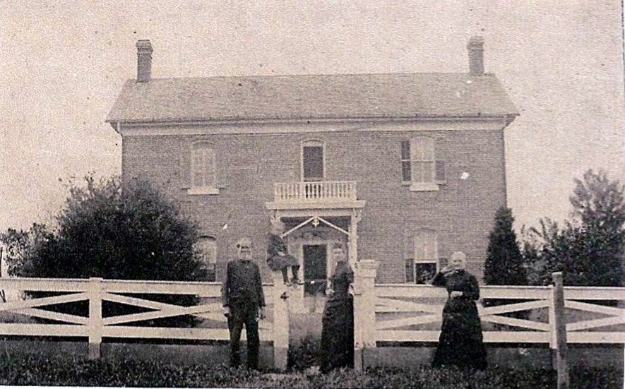William White Williams residence, Rubicon Township, Greenfield, IL
William White Williams born 9 Jul 1791 in North Carolina near the Virginia Line was said to have been an orphan at an early age. At the age of 17, he left his native state and settled near Winchester, KY, where he married Lydia Whitehurst. From there they moved to Jacksonville, IL, in 1831, remaining there for two years, before going on to Greene County, settling on a farm in Section 24 of Rubicon Township.
Lydia born in 1786 KY died 19 Apr 1858 in Greenfield at the age of 72. After her death, William married Mariah Orcutt O’Flyng 7 Nov 1860, widow of Felix Clara O’Flyng who died 16 Sep 1849. By the time of his death in 1884, at the age of 93, William had accumulated 981.11 acres in Greene County. He and Lydia were buried in the family burial grounds on the farm. During the 1970’s land use turned to grain production. In the 80’s the perimeter fence was removed and eventually the gravestones and markers were pushed over the Rubicon creek bank and buried. It is believed there were 20-25 stones at one time, two marking the graves of slaves that had been freed by the Williams family in KY and who had traveled north with the family. About 12 stones, some in good condition, some broken, were retrieved and are located at the residence of Sam and Susie Thornton in the SW ¼ of Section 17, Rubican Twp., Greene County, on the bank of Rubicon Creek, downstream from their original location.
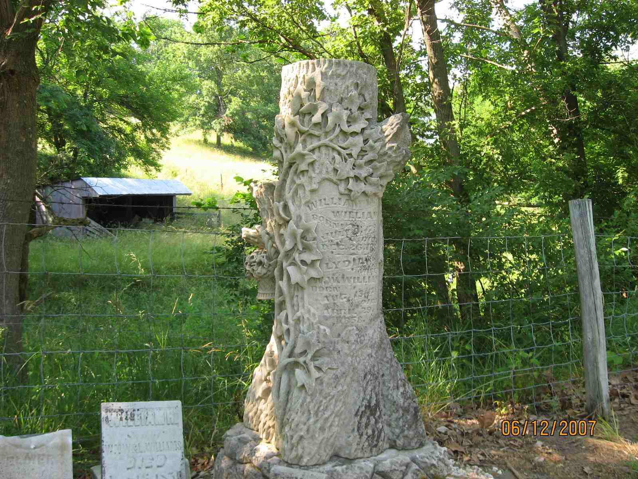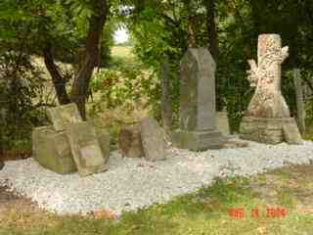Pioneers and settlers represented here are Williams & (Edwin) Henderson. These families settled on the prairie in and around Greene County as early as 1819.
Tree Trunk: Wm. and Lydia Williams Granite Stone: Edwin and Eliza Williams Henderson, Mary L. Henderson, Elmer Henderson - Broken stone No name Marker: Newton s/o Wm. W. and L. Williams - Marker Martha - Marker: Frank Wilson s/o J. A. & M. F. Stickel – Footstones: M.H. and F. S.
William and Lydia were parents of six children born in Kentucky:
Mary Ann was the 2nd wife of John Hockaday Waller. Five children: Lydia m. Stephen Reed, Frances m. John Hardtner; James m. Mary Ellen Hardcastle; Mary E. and Mary Ann.
Eliza Jane married Edwin Lee Henderson, s/o James and Mary White Henderson. In 1818 James Henderson left Ohio as a pioneer bringing his family with him and in the spring of 1819 cleared land and helped form a settlement just north of Apple Creek and east of the road from Carrollton to White Hall. Edwin’s sister, Caroline, married George Washington Allen in 1823 Greenfield. Daughter Mary Jane married William Albertus Tunnell in 1847 and parents of Allen Morse Tunnell who married Mary Ann Williams, the granddaughter of William and Lydia Williams. Edwin and Eliza had 10 children: Lydia m. Benjamin Thorpe; Martha; Angeline m. a Stilson; Mary L. died as a baby; Sarah Helen; Mary Frances m. John Andrew Stickel; Helen Amelia; Arthur E. m. Effie Lou Young; Frank m. Emma Bell; and Elmer died young.
Descendants of William W. Williams and Eliza Williams Henderson living in Greene County as of 1 Jan 2015: Lydia Suzanne and Isabelle Grace, daughters of John and Susan Thornton Lansaw; Annabeth Catherine d/o Joe and Melanie Plogger Thornton; Brooke Elizabeth d/o Josh and Sara Chapman Thornton; Allison d/o Sam III and Tracy Thornton.
Martha Elizabeth married 1st George W. Reid who died 1850; children: William m. Eliza Carson and 2nd Sarah Reed; John m. Hannah; Newton W. m. Sarah McConnell and 2nd Emily Markoe; and George W. Martha then married William Jones Metcalf. Children: Henry F. m. Mary Reid; Eva Idella m. William Gardner; and Joseph Albert m. Minnie J. Melvin. Descendant of Martha and William Metcalf still in Greene County: Robert Langley.
Two of Williams’ children died in 1850 while attending McKindree College - Newton drowned 18th Jun 1850 and in April his brother, William died of a lung inflammation.
Milton White Williams married Almira Adeline Edwards 1 Jan 1851 Greenfield. Elmira was d/o David Stowell and Almira Adeline Wilcox Edwards, early pioneers in Greene County. Nephew Herbert Newton Edwards married Maude Tunnell d/o Allen Morse and Mary Ann Williams Tunnell. Mary Ann was d/o Milton and Almira.
Story submitted by Samuel Thornton, Jr., Greene County, IL (William>Eliza>Lydia>Eliza) and Betty G. Silvey Baton Rouge, LA (William>Milton>A. N.>Edwin Lee)

